101 EAL Conversations Order Form

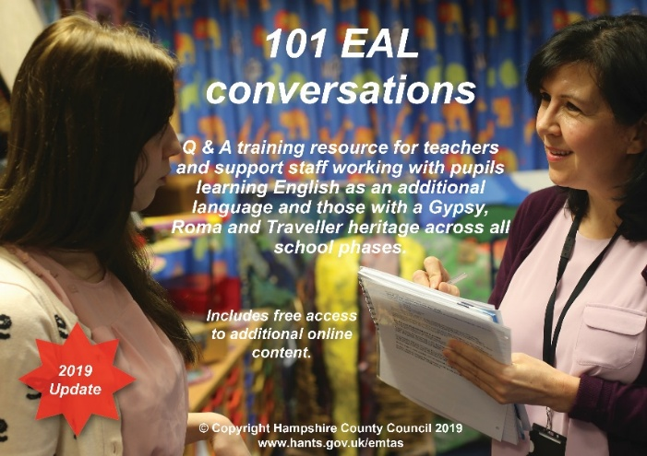

Name of Resource | Quantity | Unit Price |  | VAT | Sub Total
101 EAL Conversations – digital resource. Cross-phase Q&A training resource for teachers and support staff working with pupils for whom English is an additional language and Gypsy Roma Traveller pupils. |  | £45.00 |  | £9.00 per registration
TOTAL
Please provide full name and email address of EAL Coordinator

Your Official Order Number: |  |  | Date:
Organisation name, postal address, finance email for invoice.

Tel: 0370 7794222
Website: www.hants.gov.uk/emtas

Please send your completed order form to emtas@hants.gov.uk
Invoices can be sent to schools.

