Young Interpreter Scheme® Order Form
Tel 03707 794222 Website www.hants.gov.uk/emtas
Please note VAT (20%) only applies to non-HCC schools

Name of Resource | Quantity | VAT* | Unit Price | Sub Total
PRIMARY Young Interpreters registration (includes unlimited access to Primary Moodle and bonus materials) |  | £14.00 | £70.00
SECONDARY Young Interpreters registration (includes unlimited access to Secondary Moodle and bonus materials) |  | £14.00 | £70.00
PRIMARY & SECONDARY Young Interpreters registration (includes unlimited access to BOTH Primary and Secondary Moodle and bonus materials) |  | £23.00 | £115.00
*PRIMARY and SECONDARY Young Interpreters Guidance and bonus materials are accessible online via a private Moodle account. All orders for guidance materials must include a work email address for the Young Interpreter Co-ordinator.
Please provide email of Young Interpreter Co-ordinator:

…………………………………………………………………………………………………………………….

Young Interpreter badges (sold in sets of 10) |  | £2.00 | £10.00
Young Interpreter hat (sold individually) |  | N/A | £4.50
Young Interpreter stickers (sold individually) |  | £0.05 | £0.25p
Young Interpreter certificates (sold in sets of 10) |  | £0.50 | £2.50
Young Interpreter pencils (sold in sets of 10) |  | £1.00 | £5.00
Young Interpreter safety school tabard (sold individually) |  | N/A | £5.00
Young Interpreter notebook (sold individually) |  | £0.50 | £2.50
Young Interpreter bag (sold individually) |  | £0.60 | £3.00
Postage: (excludes HCC Schools) |  |  |  | £2.50
TOTAL
Your Official Order Number: |  | Date:
Your name and delivery address:

Please send your order to: Julie Yates, Hampshire Ethnic Minority and Traveller Achievement Service, Dame Mary Fagan House, Chineham Court, Lutyens Close, Basingstoke, Hampshire RG24 8AG. Email: julie.yates@hants.gov.uk. Tel: 03707 794222
Invoices can be sent to schools for payment. Cheques made payable to Hampshire County Council.
*VAT (20%) Excludes HCC Schools

Young Interpreter product catalogue

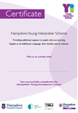 | Certificates. Sold in sets of 10.
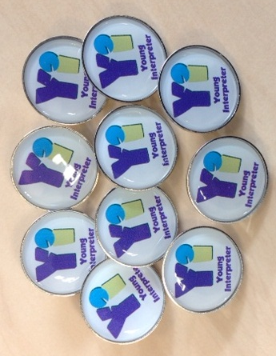 | Badges. Sold in sets of 10.
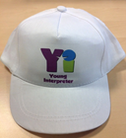 | Hats. Sold individually.
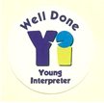 | Stickers. Sold individually.
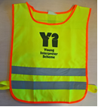 | Tabards. Sold individually.
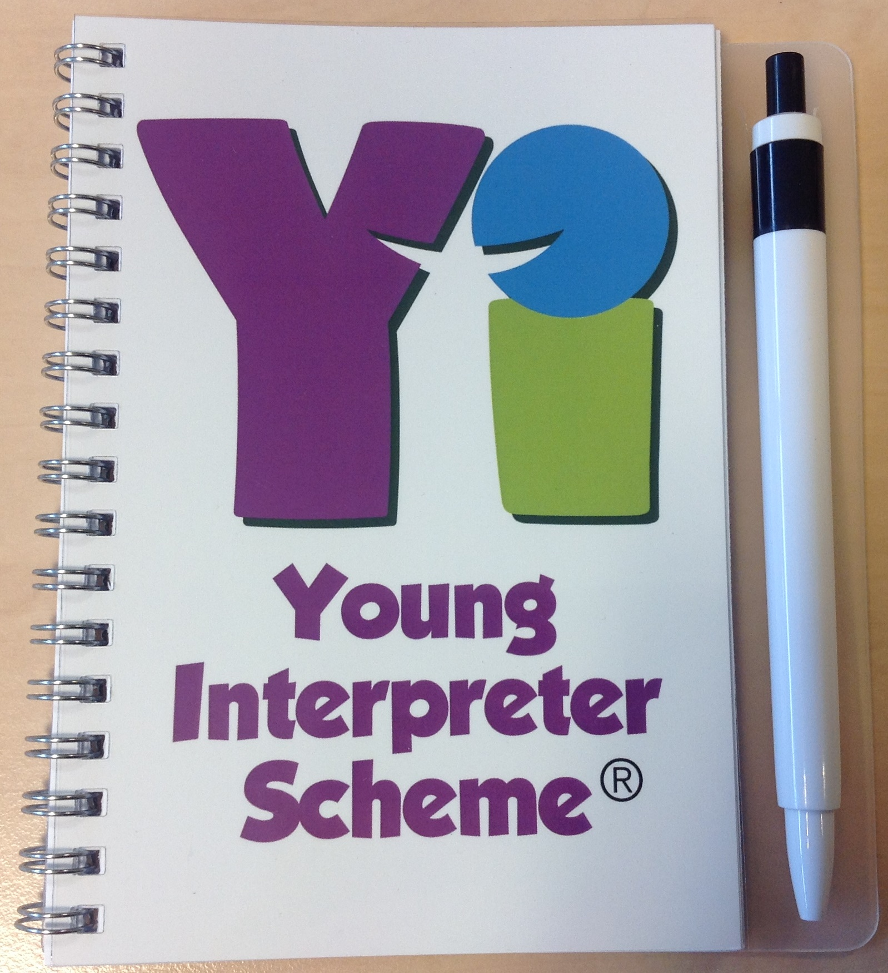 | Notebooks. Sold individually.
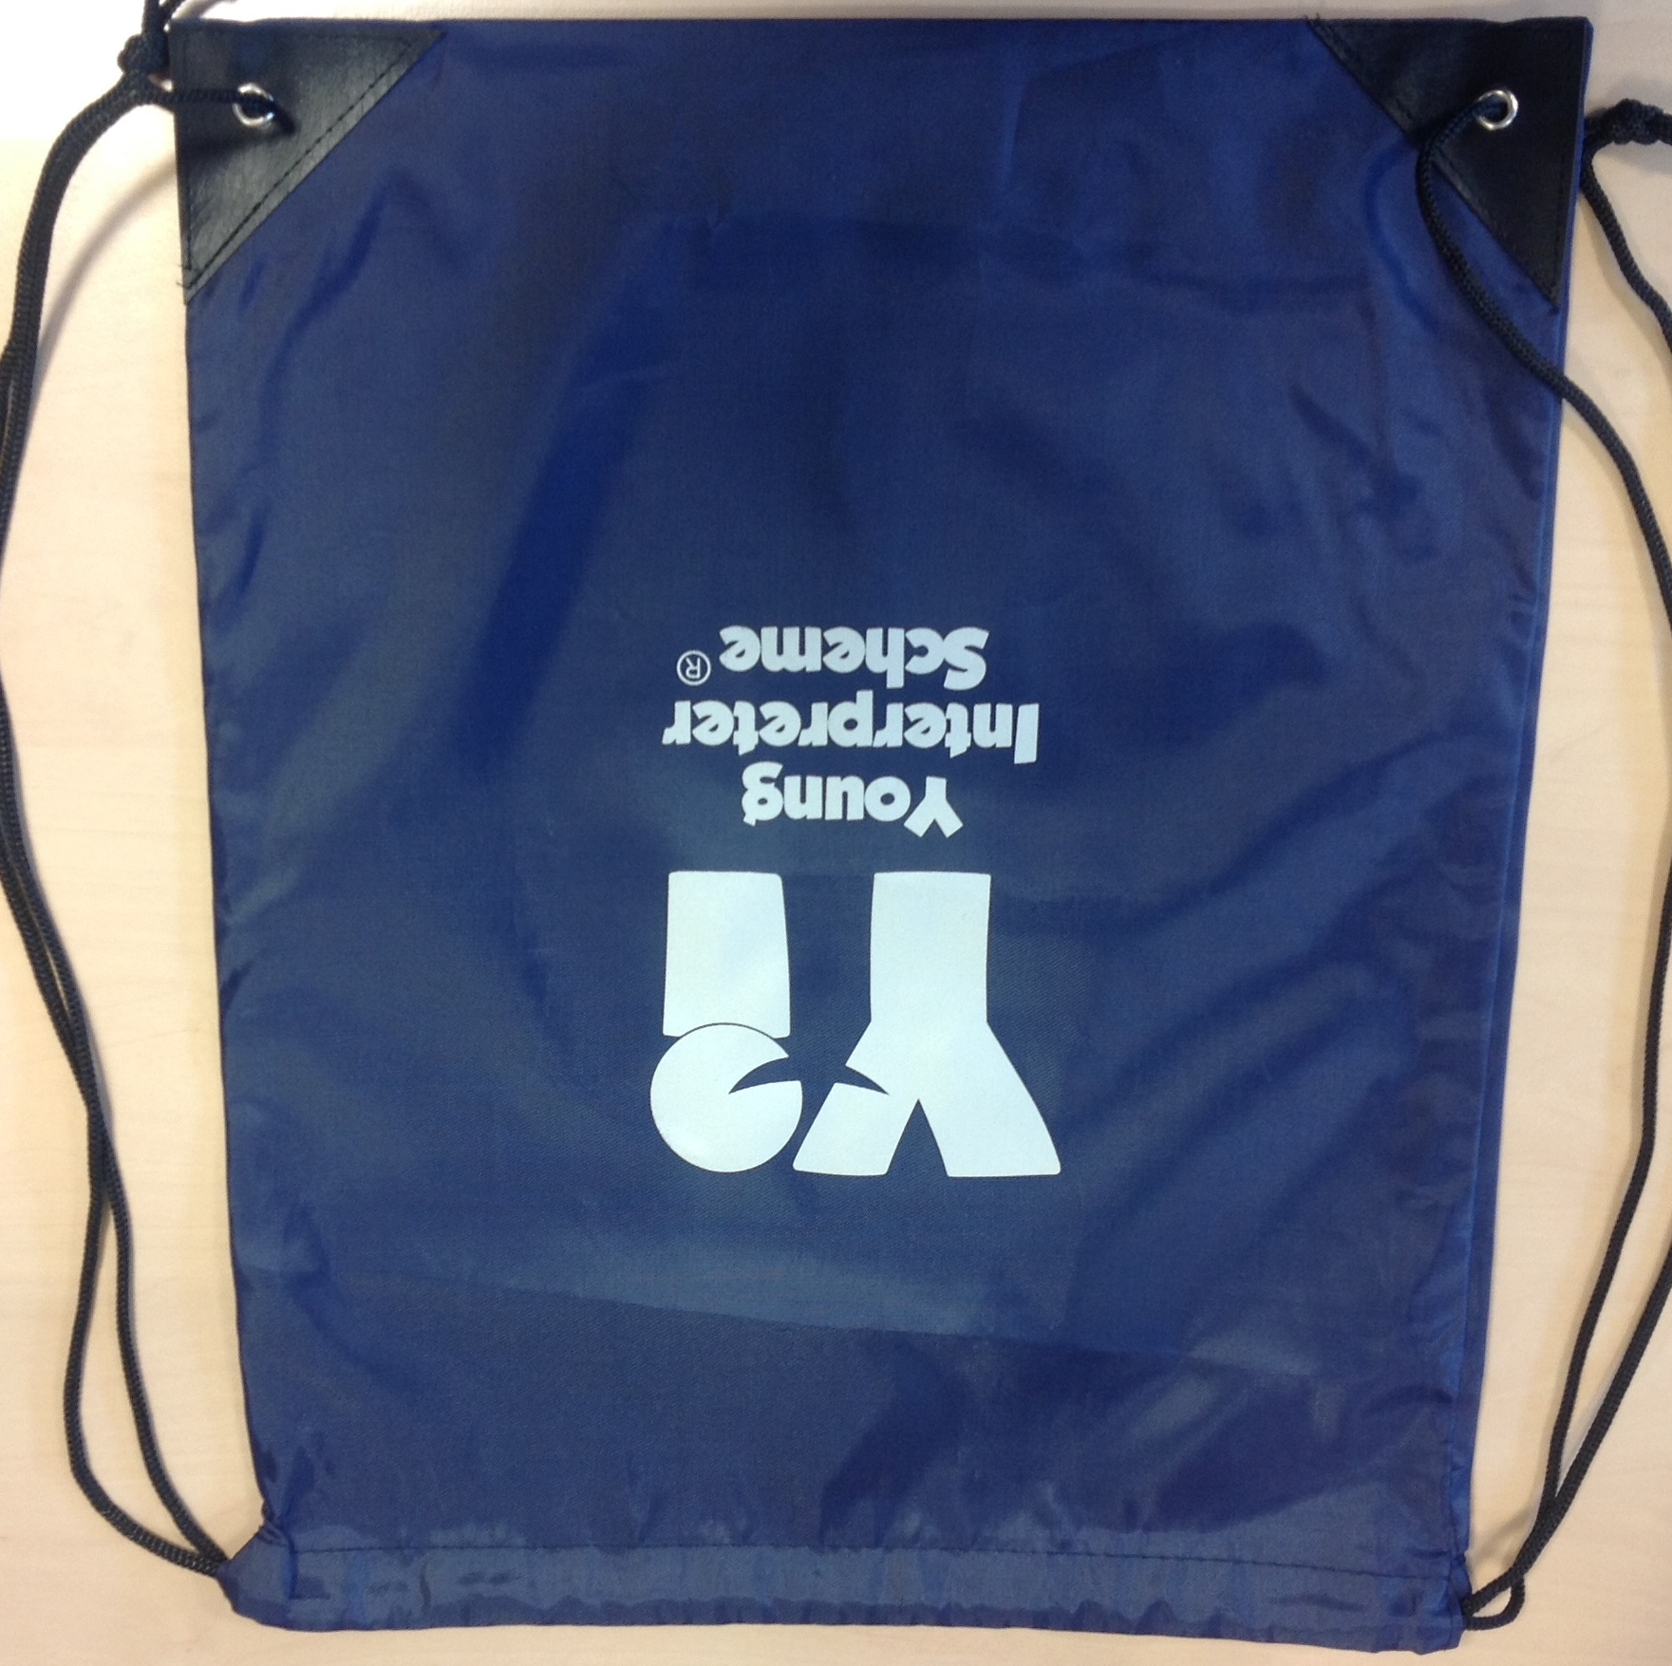 | Bags. Sold individually.
 | Silver pencils. Sold in sets of 10.

