The Young Interpreter Scheme: staff experiences of participation
Summary of findings

- Empathy, self-esteem and self-concept.
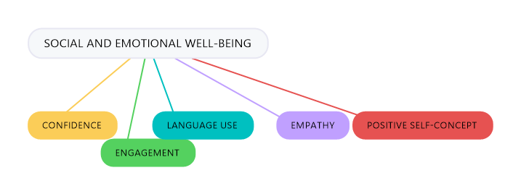
The analysis of responses to the question What changes in pupils involved in the scheme (YIs and pupils who have EAL) have you observed in terms of social and emotional well-being? resulted in five main changes reported in pupils in terms of well-being who are involved in the YIS.

Theme | Frequency of occurrence | Examples
Confidence | 22 | “more confident around school”  “Children feel more confident about themselves”
Engagement | 8 | “EAL students who are buddied are able to access more of the curriculum and settle into school quicker”  “more engaged in the school life”
Language use | 4 | “increased confidence in sharing home language”  “more confident to speak up and use their common home language”
Empathy | 5 | “They are very aware of new starters and like to help them with knowing what to do at school”  “They are more open minded and patient”
Positive self-concept | 18 | “Very positive, especially regarding self-esteem”  “Pupils are positive role models in the community and are proud to be part of the team”  “self-esteem and self-worth raised”

2) Opinions on home language of pupils with EAL.
From analyses of the data it can be concluded there was a correlation between running the Young Interpreter Scheme and positive opinions of home language use. Specifically, schools running the YIS
- were over 10 times more likely to report positive views on home language use in classrooms and throughout school than schools not running the scheme.
- were over 3 times more likely to report visibility of home languages(s) throughout their school, for example displays with phrases from different languages.
- were more likely to ask children about their home language(s)

- Intercultural awareness
The results showed that respondents whose school were currently running the YIS were more likely to report positive views on intercultural awareness throughout their school than schools not running the scheme. Specifically, schools running the YIS
- were over 9 times more likely to report overall positive intercultural awareness.
- were 10 times more likely to report that they created opportunities to develop intercultural awareness.
- were 9 times more likely to report that pupils appreciated the religious, ethnic, and cultural diversity of children in the school.
These findings demonstrate that participation in the scheme significantly increased perception and respect for cultural and linguistic diversity. Adding further weight to this conclusion is that the analysis also showed cultural and linguistic diversity was promoted as a function of participation in the YIS.

- Misconceptions surrounding concepts and use of YIs
Language status
There were examples of misconceptions surrounding the language status required of YIs. Guidance from EMTAS states that YI do not need to share a common home language. However, there were several reports that a lack of shared language between YIs and their buddies was a barrier to running the scheme effectively. These included;
- “too few pupils so languages do not overlap”
- “We have many isolated learners and no dominant L1 group.”
- “Not all languages are covered by the YI so we have had to use other children as buddies. However, the YI are a support and friendly face at play times.”

Maintaining motivation
Guidance from Hampshire EMTAS provides several methods for maintaining motivation for YIs, yet the results of this study suggest some are not utilised as much as believed. For example, only a few respondents indicated that the YIs in their school interact with other YIs on the YIs Moodle forum, collaborate with YIs in other schools and read the YI newsletter (all <10 respondents). The latter is in contrast with the fact that half the respondents indicated that they themselves read the newsletter.
Further, one respondent commented that there are “some good ideas here” in reference to the list of provided ideas for keeping YIs motivated, suggesting limited knowledge of EMTAS guidance.

Appropriate use of Young Interpreters
It is necessary to report on how YI’s are utilised in schools. Four negative statements were included of how young interpreters should not be used. Some answers were misaligned with guidance provided by the YIS, suggesting guidance is not fully adhered to. Three respondents indicated YIs support other pupils during tests, three indicated YIs interpret for a child discussing sensitive and confidential information, e.g. a disclosure, nine indicated YIs interpret during formal situations, for example parent-teacher meetings and 17 indicated YIs interpret new academic content. This study found occasions of YIs being used inappropriately.

- Effects on academic achievement
Findings from the literature on possible increases in academic achievement for children involved in language brokering schemes are mixed. This was echoed in this study by several respondents reporting that no changes in academic achievement had been observed, to some who had not considered tracking “the interpreters' achievements for academic progress”. Conversely, others reported “higher grades”, “a higher achievement overall” and “more sophisticated vocabulary with developed speaking skills.” Many responses to the question indicated that the improvement in academic achievement was facilitated by improved confidence. Consequently, more research is needed in this area, therefore, directly tracking academic achievement in this group of learners could be completed in the future.

