EMTAS Conference 2021
All in this together
Going from strength to strength
The EMTAS conference returns for 2021, continuing to deliver cutting edge, innovative approaches to working with children for whom English is an additional language (EAL), children from Black and Minority Ethnic (BME) groups and Gypsy, Roma and Traveller (GRT) children, families and communities.

Keynote Speakers
Our renowned keynote speakers will be addressing current issues from insightful and research perspectives. Eowyn Crisfield is an expert in languages across the curriculum and a Senior Lecturer at Oxford Brookes University. Sarah Coles is Deputy Team Leader of Hampshire EMTAS and a PhD student researching ‘Pathways to bilingualism: young children’s experiences of growing up in two languages’. Eowyn and Sarah will be disseminating key findings from their many years of work and research. We will also be joined by Leanda Hawkins, an HLTA in a primary resourced provision and Behaviour Lead across a Federated school in Hampshire, who will share her educational and career experiences from the perspective of a member of the Romany community.

Workshops
Delegates will benefit from two workshops equipping them with the skills and knowledge needed to develop their professional practice. The workshops will cover all Key stages and will be facilitated by experienced EMTAS staff and professionals from schools in Hampshire. There will be workshops offering cultural support, ICT programmes that support EAL in the curriculum, Supporting literacy with GRT pupils and Wellbeing Mentors showing practical tools to help support EAL and GRT pupils.

Also available are stands displaying a range of resources you can access to support you in your work in school. You can view the stands during breaks, when you will have opportunities to meet and network with other skilled professionals.

Spaces are limited so sign up now to guarantee your place at this exciting conference as we forge ahead together.

Keynote Speakers’ Biographies

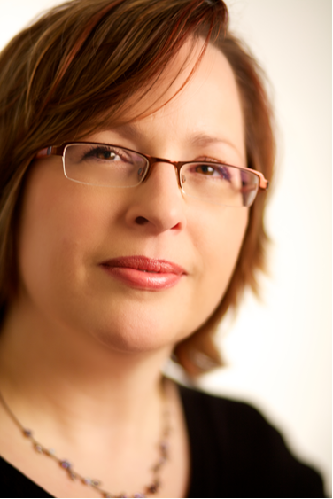 Eowyn Crisfield

Eowyn Crisfield is a Canadian-educated specialist in languages across the curriculum, including EAL, home languages, bilingual and immersion education, super-diverse schools and translanguaging. Her focus is on equal access to learning and language development for all students, and on appropriate and effective professional development for teachers working with language learners. She is author of the recent book ‘Bilingual Families: A practical language planning guide (2021) and co-author of “Linguistic and Cultural Innovation in Schools: The Languages Challenge” (2018 with Jane Spiro). She is also a Senior Lecturer in TESOL at Oxford Brookes University.

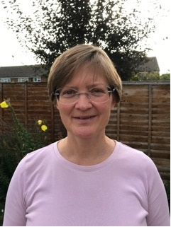 Sarah Coles

Sarah Coles has worked at Hampshire EMTAS for 24 years, first as a member of the Specialist Teacher Advisor team and latterly as the Deputy Team Leader.

Sarah’s presentation will focus on her research into the language-learning experiences of young, UK-born bilingual learners, growing numbers of whom join Foundation Stage each year. Sarah explores the home and English language skills these children bring with them into their Year R classrooms and how their language preferences shift through their first year of compulsory education. Sarah’s longitudinal study focuses on children with Nepali or Polish in their backgrounds. These two languages represent the greatest number of referrals made by schools to Hampshire EMTAS, hence the relevance of the research to the Hampshire context.

 Leanda Hawkins

Leanda is from a Romany family with rich culture that has been present in Hampshire for centuries. She went on to Higher Education and has carved a career supporting children with special educational needs. Her motivation is to help all children progress and thrive through education.

To book your place:

Date/time: Friday 15th October 2021

Course code: EMTAS Conference HCC_CS_HTLC_DSPP_00004CON
Location: Holiday Inn, Winchester

Cost: £150 sub £180 full (including lunch and refreshments)

For further information and online booking please visit:

HCC employees:

HTLC / HIAS Learning Zone Guidance Documents

The Learning Zone for HCC staff

The Learning Zone for external customers

Article 30 United Nations Convention on the Rights of the Child

Every child has the right to learn and use the language, customs and religion of their family whether or not these are shared by the majority of the people in the country where they live.

