Young Interpreter Scheme® Order Form
Tel 03707 794222 Website www.hants.gov.uk/emtas

Name of Resource | Quantity | Unit Price | VAT (20%)  (Excludes HCC Schools) |  | Sub Total
PRIMARY Young Interpreters registration (includes unlimited access to Primary Moodle and 1 year’s access to subscription page)* |  | £70.00 | £14.00 per registration
SECONDARY Young Interpreters registration (includes unlimited access to Secondary Moodle and 1 year’s access to subscription page)* |  | £70.00 | £14.00 per registration
*PRIMARY and SECONDARY Young Interpreters Guidance materials and yearly subscription page are accessible online via a private Moodle account. All orders for guidance materials must include a work email address for the Young Interpreter Co-ordinator. Access to the subscription page can be renewed yearly through Moodle.

Please provide email of Young Interpreter Co-ordinator:

…………………………………………………………………………………………………………………….

Set of 10 Young Interpreter badges |  | £10.00 | £2.00 per set
Young Interpreter hat |  | £4.50 | N/A
Young Interpreter stickers |  | £0.25p per sticker | £0.05 per sticker
Set of 10 Young Interpreter certificates |  | £2.50 | £0.50 per set
Set of 10 Young Interpreter pencils |  | £5.00 | £1.00 per set
Young Interpreter  Safety school tabard |  | £5.00 | N/A
Young Interpreter notebook |  | £2.50 | £0.50 per notebook
Young Interpreter bag |  | £3.00 | £0.60 per bag
Postage: (excludes HCC Schools) |  |  |  | £2.50
TOTAL
Your Official Order Number: |  | Date:
Your name and delivery address:

Please send your order to: Julie Yates, Hampshire Ethnic Minority and Traveller Achievement Service, Dame Mary Fagan House, Chineham Court, Lutyens Close, Basingstoke, Hampshire RG24 8AG. Email: julie.yates@hants.gov.uk
Invoices can be sent to schools for payment. Cheques made payable to Hampshire County Council.

Young Interpreter product catalogue

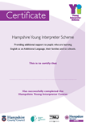 | Certificates. Sold in sets of 10.
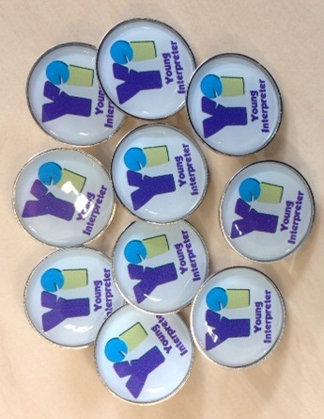 | Badges. Sold in sets of 10.
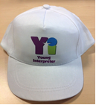 | Hats. Sold individually.
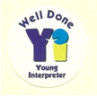 | Stickers. Sold individually.
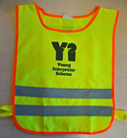 | Tabards. Sold individually.
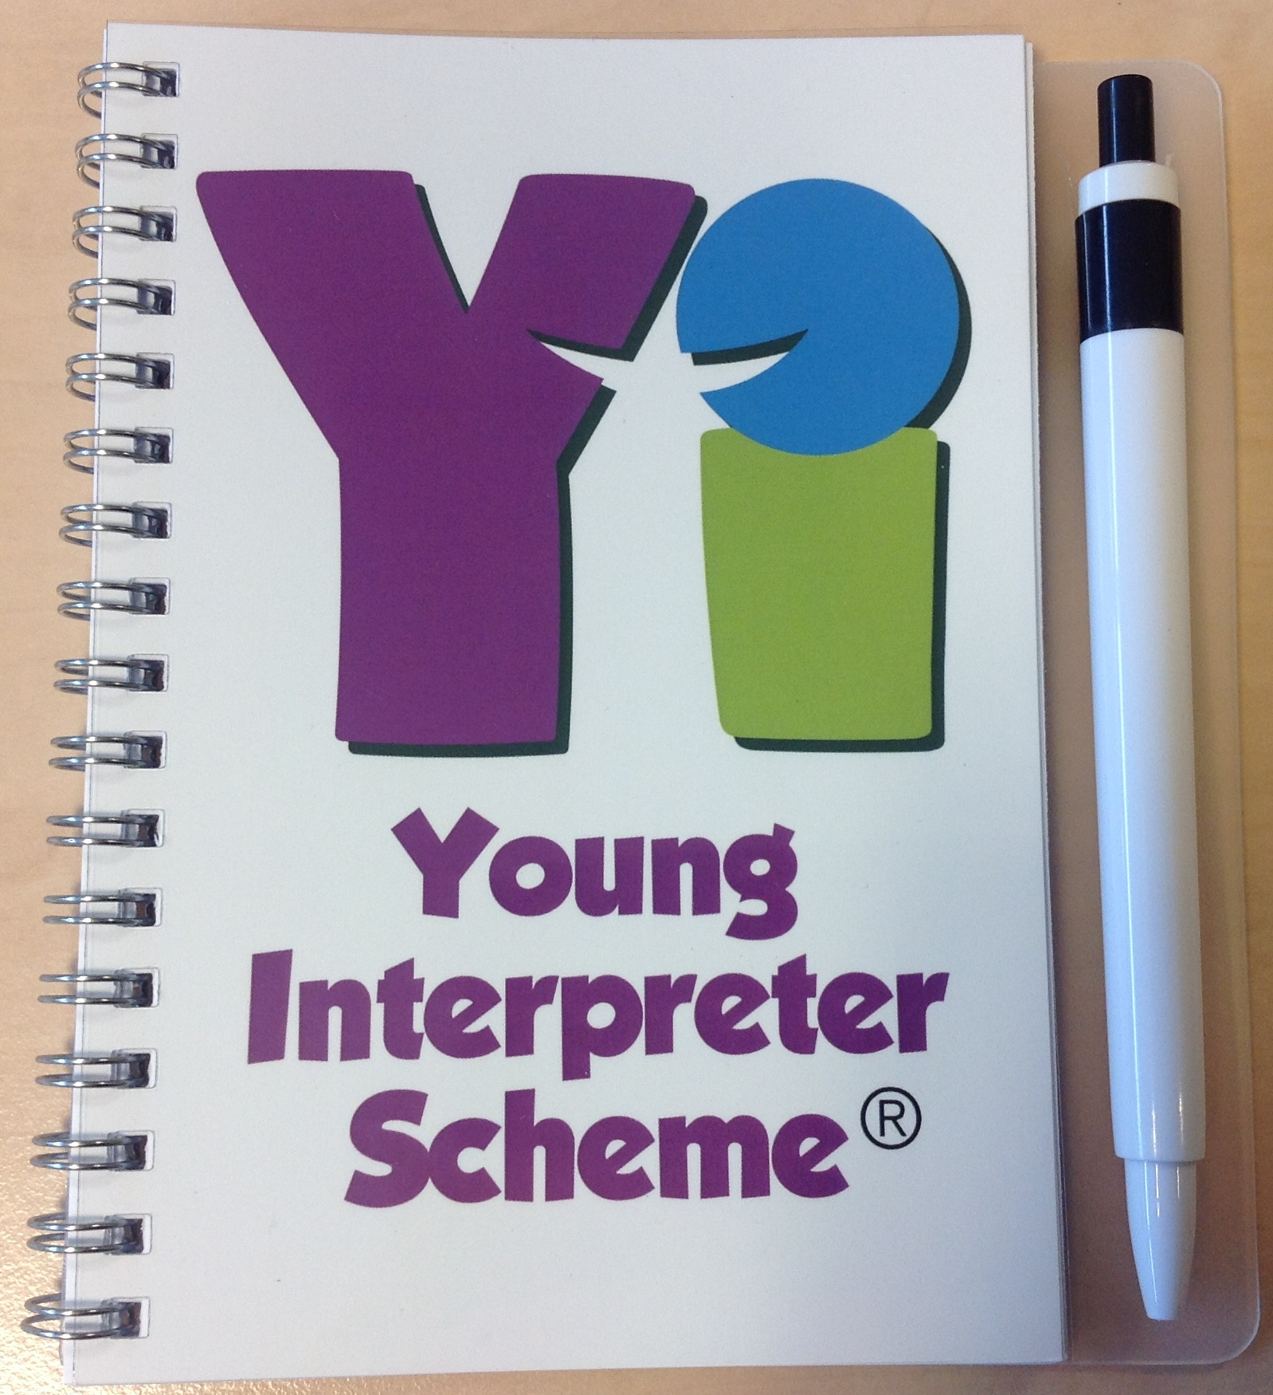 | Notebooks. Sold individually.
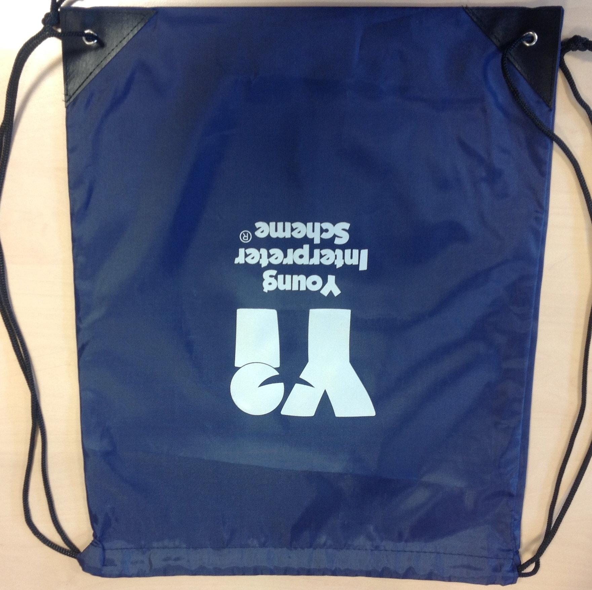 | Bags. Sold individually.
 | Silver pencils. Sold in sets of 10.

